Log into domain.com

If you have purchased a domain name, example ‘learn-devops.online’ it will be shown and you can click ‘**Manage’**.

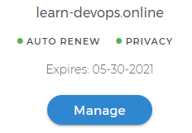

To create a SUBDOMAIN click ‘**Pointers and Subdomains**’ at the left pane and then click ‘**+ Add Subdomain**’, in our use case we would like to create ‘kops.learn-devops.online’ SUBDOMAIN.

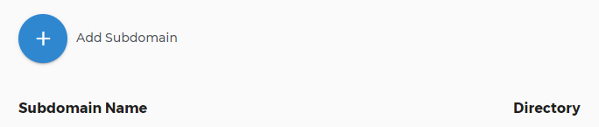

Enter ‘**kops**’ as Subdomain Name and ‘**/**’ as Directory (URL prefix), and click ‘**Save**’.

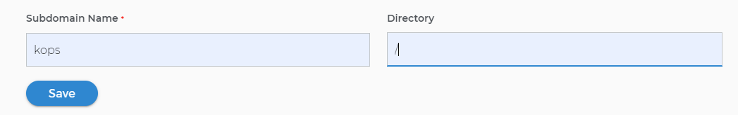

To create NS Records as provided by AWS Route53 Hosted Zone, click ‘**DNS & Nameservers**’ at the left pane, and then click **‘DNS RECORDS**’. Click ‘**+ Add DNS Record**’.

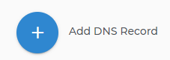

Enter:

‘**kops**’ as Name

‘**NS**’as Type

‘**ns-1633.awsdns-12.co.uk**’ as Content

‘**1 Week**’ as TTL (Time To Live)

Leave blank for Priority

Click ‘**Add DNS**’

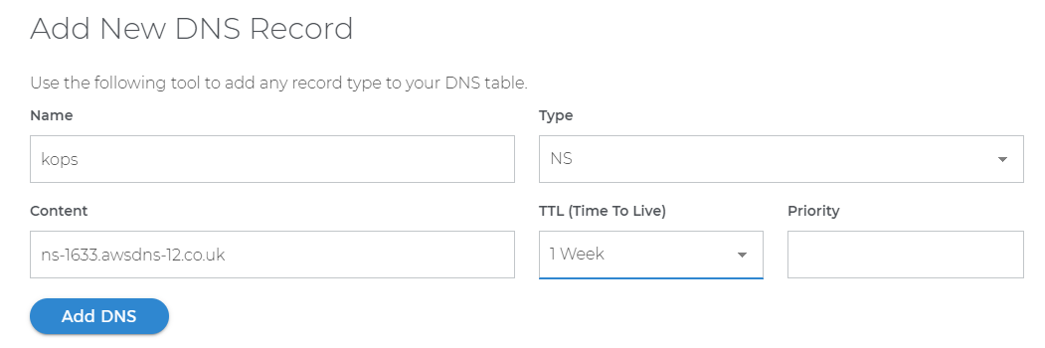

Repeat for the rest of the three NS Records, finally:

